**Setup the EPAS Service Schedule**

1. Copy the TaskTimer.exe file to a new folder on C:\
2. Setup the Task Scheduler

Server Manager -> Tools -> Task Scheduler -> Create Task

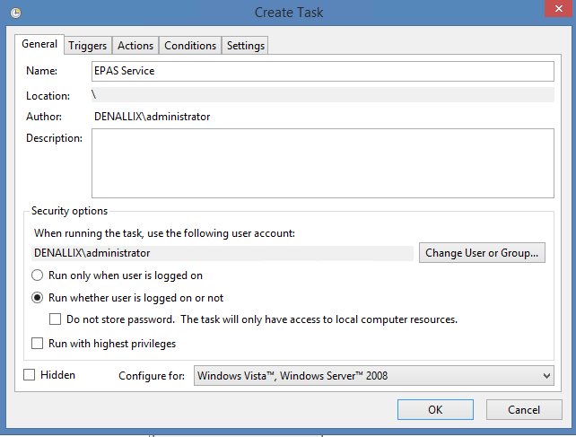

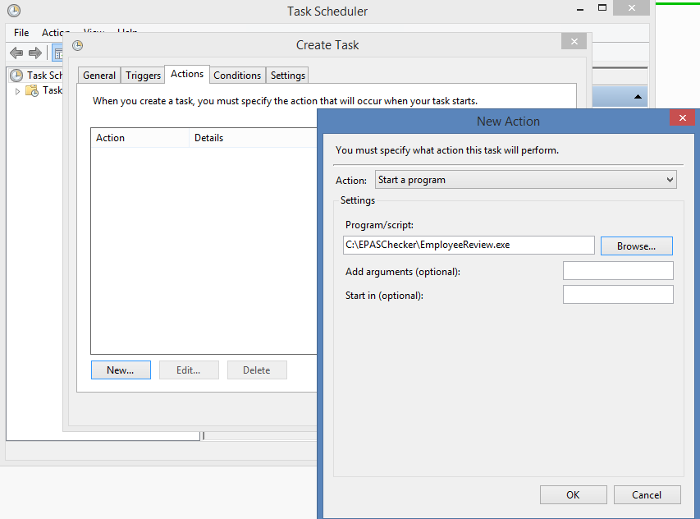

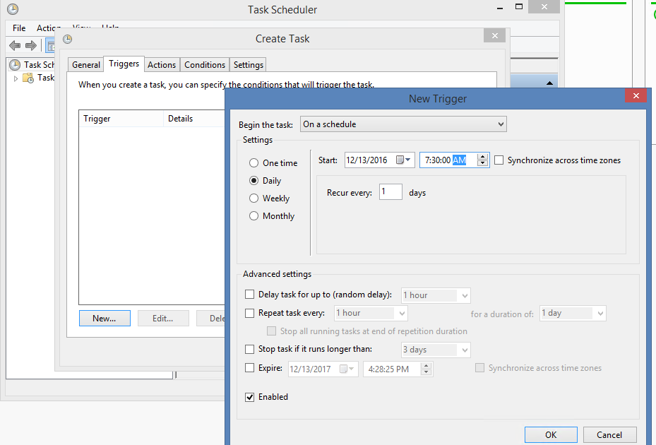

Click Run

